The first step:
Put the U8glib library file in the libraries development environment of arduino-1.0.5;

The second step:
Open the development environment of arduino-1.0.5, click Tools---Borad----Arduino on the Mega or 2560 Mega ADK, then check the corresponding COM port;

The third step:
Select download firmware

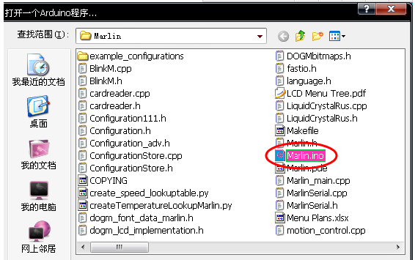
Note: here you need to enable a line of code,
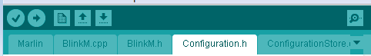

Check Coniguration.h, and find “//#define REPRAP_DISCOUNT_FULL_GRAPHIC_SMART_CONTROLLER”
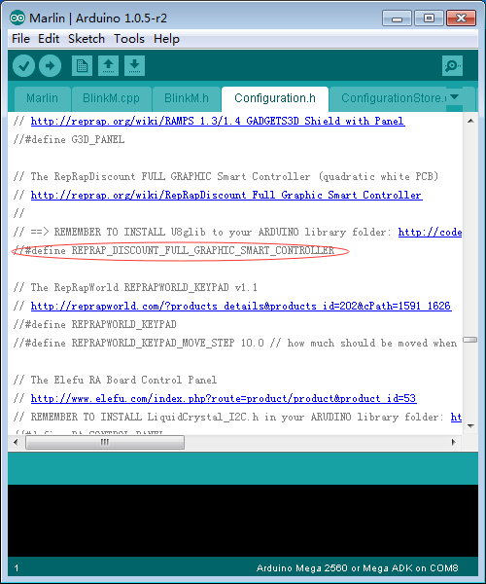
Remove the “ // “ symbol in front of the code,
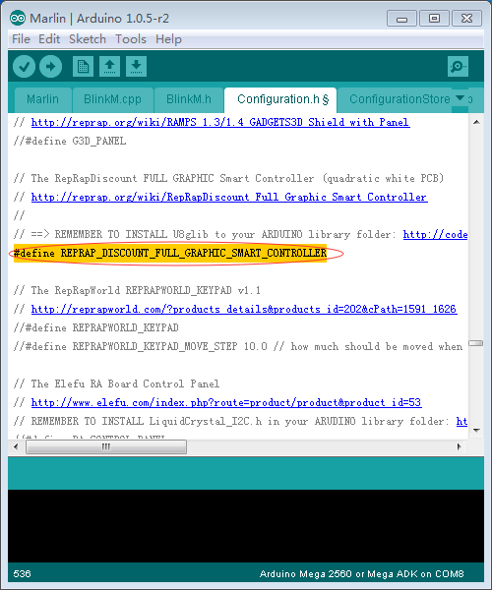

After finish, click compile, if no problems, then click the download button
The fourth step: the mode of connection;
